|  |  |
| --- | --- |
| Image result for university of victoria letterheadSunil **Kumar** | [*sunilkumarsheoran@gmail.com*](mailto:sunilkumarsheoran@gmail.com)  *+1-6043674432*  [linkedin.com/in/sunilkumarsheoran](http://www.linkedin.com/in/sunilkumarsheoran)  *ECS 412, University of Victoria,*  *Victoria, BC, Canada. V8P 5C2* |

I am a Master of Computer Science student at the University of Victoria. I have 3 years of software development experience with software product companies including Drishti-Soft Solutions aka Ameyo and Zillious Solutions. Seeking co-op opportunities where I can fully utilize my skills for the success of the organization and learn new skills for the cutting edge of technologies in the industry.

|  |  |
| --- | --- |
| Education M.Sc. in Computer Science Jan 2019 – Expected Jan 2021University of Victoria – 7.33 / 9.0 GPA Projects: Training a DQN agent for Coinrun ([GitHub](https://github.com/Unimax/coinrun-dqn-pytorch)) and Matchmaking for online multiplayer games ([GitHub](https://github.com/Unimax/CSC562-FinalProject-Matchmaking-for-games-using-open-match)). B.Tech. in Information Technology Aug 2010-May 2014NIT Durgapur - 8.10 / 10.0 CGPA Projects: Collage Study Point Website ([GitHub](https://github.com/Unimax/studentcorner)), Digital Clock on Multisim and Exploration bot. 12th & 10th CBSE March 2007 & March 2010K V Bengdubi - 85.8 % & 79.8 %Projects: Book Shop Management, Tic Tac Toe bot | Technical Skills   * Languages : Java, JavaScript, Python, Golang, PostgreSQL, MySQL, C, C++, PHP, CSS, HTML, Shell. * Tools: Docker, Kubernetes, Google Cloud Platform, Office, Adobe Photoshop, gRPC, Swagger, REST APIs, Git, GWT, JDBC, Hibernate, Eclipse, PyCharm, OOPs, Data Structures, Deep Learning, Electron, Angular, Slack, Eclipse Modeling Framework, Jasper Report, uxpin. * Operating Systems: Linux, Windows |

# Experience

## Technical Associate / Zillious Solutions, New Delhi, India. July 2018 – Dec 2018

### Implemented a solution for a long-standing issue (java enum limit) requiring minimum changes in the application.

### Design and developed support for customizable voucher and integrated multiple payment gateways.

### Integrated pre-developed machine learning model into the application for finding duplicate hotels.

## eSports Player / Ragequit eSports Solutions, New Delhi, India. Nov 2016 – Jan 2018

### From Dec 2016 to June 2017 was part of DOTA 2 ESports team Sponsored by Ragequit eSports Solutions, New Delhi.

### Runner up in COBX National DOTA 2 tournament (Buriza Team, Hyderabad, May 2017).

### Won Playtonia DOTA 2 tournament (Nefarious Team, Delhi, Aug 2017).

### Won Indian LAN Gaming Cup DOTA 2 tournament (Nefarious Team, Delhi, Oct 2017).

### Runner up in Aorus Land DOTA 2 National tournament (Nefarious Team, Bangalore, Jan 2018).

## Software Developer / Drishti-Soft Solutions, Gurugram, India. June 2014 – Sep 2016

### Majorly worked on Ameyo Report (GWT based front-end and Jasper based backend) this includes UI Renew, transformer (de-normalize data for reporting) modeling to ease the generation of new transformers and backend enhancements.

### Created a Report Scheduler (Quartz library) with support for Centralized Reporting (Ameyo ART) and Graphical Reports.

### Increased performance for a large customer’s database (PostgreSQL) by 80-90% using table partition and Multicolumn Indexes.

### Increased the Stats Manager’s performance by 60% using cache (SoftHashMap) for reflective calls.

### Developed a context-aware Report Designer: Front-end GWT UI filled with generated data based on Model instances (.xmi) and output from the UI is a Model (EMF) object (.drxml) which converted by backend into a jasper-based object (.jrxml).

### Created Magic Numbers: Predicts hardware requirements (CPU, RAM, and HDD) based on customer requirements.

### Automate HDFC collection process. Fresh UI, Integrating HCP for storage, SSO Authenticating server & Centralized Exclusion.

### Awarded with Excellence Award 2016 and won /tmp 2014 (10 days 24x7 coding event).

### Part of the Hiring team for the 2016 and 2017 batches. (Question preparation, Interview Rounds and training after hiring).

## Software Developer Intern / Morphing Machines, Bangalore, India. June 2013 – Aug 2013

* Designed and developed the front-end interface for a research project called ‘Development of A Flexible Framework for A Network On Chip’. We wrote a research paper about it ([GitHub](https://github.com/Unimax/studentcorner/blob/master/VLSI2014Paper.pdf)).
* UI starts with a 4 page Wizard then shows [EMF](http://www.eclipse.org/modeling/emf/) based resulted graph using [Graphiti](https://eclipse.org/graphiti/) and finally produce a XML for the python written scripts which run and produce [VHDL](https://en.wikipedia.org/wiki/VHDL) based back-end [NOC](https://en.wikipedia.org/wiki/Network_on_a_chip).

# Activities

**After College:**

* TOEFL exam scored 95/120 (Jan 2018).
* Completed Spoken English Upper Intermediate course with Very Good result from British Council, New Delhi.

**During College:**

* Attended Workshops:

Ethical hacking & Information security by Kyrion Digital Securities 2010. (In 1st year).

Photoshop workshop in 2011.

Android workshop in 2012.

* + - * + Participated in contests:
* 1st position in behind the Scene in MuKTi ‘13. (coding event).
* 1st position in InCanity in MuKTi ‘13. (coding event).
* 2nd Position in Simplex in ANK ’12. (coding event).
* Participated in National Robotic Contest 2013 Pune-India.

**During School:**

* + 82% Marks secured in Junior NTSC Mathematics. (Jan 2005)
  + MERIT in First Nationwide Biotechnology Olympiad with All India/state/school Ranks: 696/11/2 (Aug 2006)
  + Distinction in International Assessments for Indian Schools Science with Top 4%.
  + Distinction in International Assessments for Indian Schools Math with Top 5%.
  + Participated in NSE in Astronomy 2008-2009 (Senior Level) Among top 10%.
    - * Ranked among the 2.4% of all student appeared in AIEEE-2010.

**Extracurricular activities:**

* + - * Selected for 35th ,36th ,37th K.V. National Sports meet in chess after getting 3rd, 1st and 2nd position in Regional Sports meet in 2007,2006 and 2005 respectively
      * Participated 3 times in 8-10 Days High Altitude Trekking Programme (Manali, Shimla) and coved 110 K.M. and gained 12000 feet height.

**Hobbies**

* **Video Games** (2nd in COBX and Aorus Land 2017 National DOTA 2 tournament, Won Playtonia & Indian LAN Gaming Cup)
* **Karate** (Green belt Shūkōkai Karate)
* **Solving Programming Problems** (1st place in behind the Scene and InCanity in MuKTi ’13 and 2nd place in Simplex in ANK ’12)
* **Playing Chess** (3rd, 1st and 2nd position in Regional Sports meet in 2007,2006 and 2005. Hence went to Nationals 3 times)
* **Watching Movies & TV Shows**
* **Listening to music**
* **Football**

**References**

* **Sahil Gandhi (**[sahilgandhi2011@gmail.com](mailto:sahilgandhi2011@gmail.com)**) –** Product Evangelist, Drishti-Soft Solutions aka Ameyo.
* **Dr. Hausi Müller** ([hausi@uvic.ca](mailto:hausi@uvic.ca)) **–** Professor, University of Victoria.

Practice:-

|  |  |  |  |
| --- | --- | --- | --- |
| **Common Questions** | **Project 1** | **Report Designer** | **Project 3** |
| Challenges |  | Complex model, object to ui |  |
| Mistakes/Failures |  |  |  |
| Enjoyed |  |  |  |
| Leadership |  |  |  |
| Conflicts |  |  |  |
| What You'd Do Differently |  |  |  |

|  |  |  |
| --- | --- | --- |
| **Data Structures** | **Algorithms** | **Concepts** |
| Linked Lists | Breadth-First Search | Bit Manipulation |
| Trees, Tries & Graphs | Depth-First Search | Memory (Stack vs. Heap) |
| Stacks & Queues | Binary Search | Recursion |
| Heaps | Merge Sort | Dynamic Programming |
| Vectors I ArrayLists , Hash Tables | QuickSort | Big 0 Time & Space |

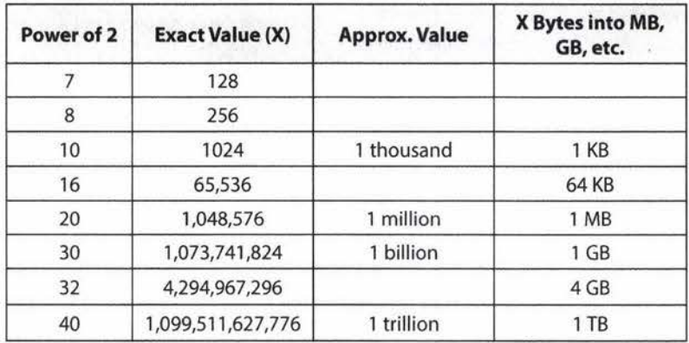

bottlenecks

unnecessary work

Duplicated work